Donald Trump is Still God's Choice, Trump vs. Clinton
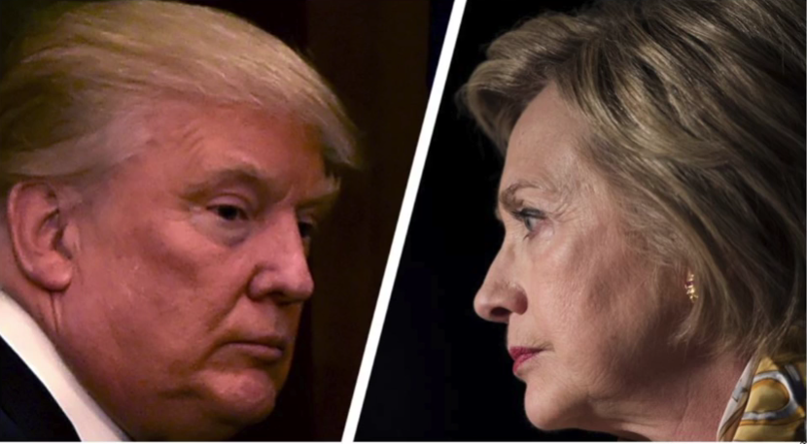
October 20, 2016

May we all rely on the Lord’s judgment and not our own, Heartdwellers. And may our hearts be in one accord with Holy Spirit. Amen.

I want to take a moment and thank those of you who donated. Valerie is taking sizes for the children's jackets and she's going to be getting them this weekend. Thank you so very much.

Well, tonight I was not thinking real straight - nothing new about that! I sent a friend to Kentucky Fried so I could concentrate on the channel and working on music for a few days and I sent them out to get some chicken. Mind you, this is a once a year or once every two years treat - we never do this. I didn’t realize until after I had sent them that this was a fasting/abstinence night for the presidential debates and election.

Once I realized my error, I thought, 'I can’t eat that chicken.' I sat down to speak with the Lord and began repenting.

I am so sorry Lord, I wasn’t thinking at all.

He replied, “You had a moment of weakness and indulgence. You may eat one piece."

Oh, thank You, Jesus, I wasn’t going to eat any…it would have been hard. Do you have something you want to share with us tonight?

He began, "Be watchful. Your enemy knows your weaknesses. You are never alone, Clare. If you could see right now, you would see that a very gross demon put that in your head, and had you checked with Me, I would have removed the desire.

"But now that you’ve corrected yourself…just one piece, no more. That will be your offering. Find something else to offer Me tonight. You see? You’re not hopeless, just a bit impulsive."

So, I offered more than one biscuit and a Dr. Pepper. It doesn't seem like much, but what is fried chicken without a Dr. Pepper? I don't know...

Anyway, the Lord launched into the message right after that.

"My people, your offerings are making an impact, but so much more is needed. There are terrible slanders against this man (Donald Trump) and they are not all true. Anyone who raises their head against the Monster will be lied about in every circle. The problem is, that most Americans are too lazy to research and find out if what was said is true. They just assume it, because it’s in the media. And that’s the same mistake the German people made in Hitler’s rule.

"If you want to know the truth, come to Me. If you can’t hear Me, then find someone who does and ask them. What is at stake right now is not Mr. Trump’s marriage, nor his character traits, nor his personal business - for if the truth were told, you have those looking respectable who were present when a sacrificial infant was slain and they drank her blood.

"So you see, you really don’t see. You hear, but you don’t really hear - not the truth, that is. You see and hear a facade, a socially acceptable mask, and beneath it Satan and his minions are pulling strings to slaughter all the Christians world-wide, but especially in America.

"If you are a Christian, you are slated for death in this country, unless another comes to power and at the very least delays it for a few years. Nevertheless, I will remove My church in her glory. But times until then will not be easy.

"But now I am asking you to pay very close attention to Me and not the media. If you want to preserve your country, you do not have a choice on who to vote for. I have already made that choice for you.

"In the meantime, this man is learning a whole new way of living and thinking. He did accept Me as his savior - he did. Now, he is finding out how detestable his behavior has been all these years. He is deeply ashamed of himself, as he should be. But not everything said about him is true. There are many, many lies and manipulations to convince the non-thinking public he is unfit for the job and a scandal.

"I am standing here waiting for you, My People. I have drawn a line in the desert, even as Moses did when he confronted Korah. I am not suggesting that Mr. Trump is morally cleaner and free from error than Mrs. Clinton. I am simply saying he is My choice, because he will do My will and bidding. I have chosen him to lead this country back into a healthy state, that at the very least the structure that upholds your rights will be intact. There will come a time when none of that matters, but in the meantime, I have chosen him to lead.

"So I am standing here and asking you to choose: are you on My side or the enemy’s side? Your decision has life-long consequences. This is not about choosing the most socially acceptable candidate. This is a war you're in. And you have the power to overcome the enemy right now."

And I just wanted to mention, for those of you who are not familiar with the rebellion of Korah in Numbers. The Israelites were out in the desert, it's in Numbers 16. And the rebellion - and I'm going to quote here from gotquestions.org.

"The rebellion of Korah demonstrates the grim consequences of usurping the authority of God and of those whom He has chosen to be leaders of His people.

“Korah was the oldest son of Izhar, who was the son of Kothath of the tribe of Levi. Korah, then, was of the same tribe as Moses and Aaron. He led a rebellion against Moses and Aaron, accusing them of exalting themselves above the congregation of the Lord (Numbers 16:1-3).

"Korah was not alone in his charge. He gathered 250 other men to challenge Moses’ authority as well: they complained “You have gone too far! The whole community is holy, every one of them, and the Lord is with them. Why then do you set yourselves above the Lord's assembly?” (Numbers 16:3)."

Can you imagine that? After he led them through the sea, the Red Sea and everything? Oh my gosh...

"Obviously, Korah thought that he could do a better job leading the people than Moses was doing. But by leading this revolt against God’s divinely appointed leaders, Korah was actually revolting against God (Numbers 16:11).

"Moses proposed a test to prove the source of his authority. Korah and his followers did not pass the test, and God opened up the earth and swallowed the rebels, their families, and all their possessions. Furthermore, “fire came out from the LORD” and consumed the other 250 men who were party to Korah’s rebellion. The rest of the Israelites were terrified and fled (Numbers 16:31-35).”

This is about rebellion, and gathering a force against Moses to rebel against him as the leader and the head. It's interesting, 'cause I went to the Scriptures for a reading and I opened to Ezekiel (I can't remember which chapter). But it was when He sent Ezekiel to the Israelites to prophecy to them and he said they won't listen. You know, they're stiff-necked, stubborn, hard people and they won't listen. That was the warning that they were given about Jerusalem's destruction. I hope we're not in that category right now. I really do hope we're not in that category.

But what the Lord is basically saying is that He has made a choice. And it's not the same choice that Korah and his followers made, but He has made the choice and He has divinely appointed someone. And so, my heart is to follow what the Lord wants. Because He alone knows the outcome. He knows who's going to do the right job and the best job. And the enemy will come up with every argument against the Lord's choice, to try and dissuade people from following the Lord's choice. Those Christians who are sensitive and they know the Lord has chosen him will stand with the Lord against the rebellion of His people, who have already elected a disastrous president for 2 terms. And we're just on the brink of losing everything, because of this man.

So, the Lord bless you, dear Heartdwellers. And normally I don't get involved politically at all with anything, but I bring this up simply because the Lord has brought it up. And I pray that we can all back him in this decision. And if you're not voting, please pray for the right choice. Please pray that the Lord will have His way in this election. So much of the survival of this nation depends upon it.

